SIGNUP SCREEN
Exercise #02
Flutter Developer Bootcamp

Purpose
This Exercise defines a Flutter screen for user signup. It includes input fields for name, number, and password, along with buttons for signup and social media login.

Problem
The Flutter Exercise defines a signup screen with fields for name, phone number, and password, along with social media signup options. It's structured using a Scaffold, SingleChildScrollView, and Column, stacking UI elements vertically. The screen includes an image, text prompts, input fields, a signup button, social media icons, and a login prompt. Overall, it offers a straightforward user interface for account registration.

How to Solve
1. Checkout the workshop from Git Repo:
git clone -b <user-branch> <repo-URL>
2. Open the root folder inside VS Code
3. To build the app click the run option in the main method { }
4. Logo:
- Centred image from a URL.
5. Text Fields for User Input:
- Name input field.
- Phone number input field.
- Password input field with visibility toggle icon.
6. Signup Button:
- Elevated button with "Sign Up" text.
- Full-width button with specified height.
7. Social Media Login Buttons:
- Icon buttons for Facebook, Google, and Apple.
- Centred horizontally in a row.
8. Prompt to Log In:
- Text prompting users to log in if they already have an account.
9. Layout Structure:
- Uses Column for vertical arrangement of widgets.
- Uses Row for horizontal arrangement of social media login buttons.
- SingleChildScrollView for making content scrollable.
- Padding for spacing around the main content.

You Will Achieve

This Flutter code achieves the creation of a signup screen for a mobile application. Here's a breakdown of its key features:
- Scaffold and Styling:
  - Uses Scaffold to create the basic visual structure of the screen.
  - The background colour is set to white.
- SingleChildScrollView:
  - Ensures that the screen is scrollable, which is helpful when the keyboard appears or if the content overflows.
- Padding and Column:
  - Uses Padding to add horizontal and vertical padding around the content.
  - Uses Column to arrange widgets vertically.
- Logo and Image:
  - Centres an image at the top of the screen, which could be a logo or an illustration related to sign-up.
- Text Widgets:
  - Displays a header ("Create Your Account") and a subheader ("Create an account so you can manage your personal finances.").
- Input Fields:
  - Three TextField widgets for user input: name, phone number, and password.
  - The password field uses obscureText to hide the text input.
- Sign Up Button:
  - A centred ElevatedButton for submitting the signup form.
- Social Media Signup Options:
  - Displays a text ("Sign Up With") followed by three IconButton widgets for Facebook, Google, and Apple sign-up options.
- Login Redirect:
  - Text at the bottom to redirect users who already have an account to the login page.

Screenshots

Expected Output
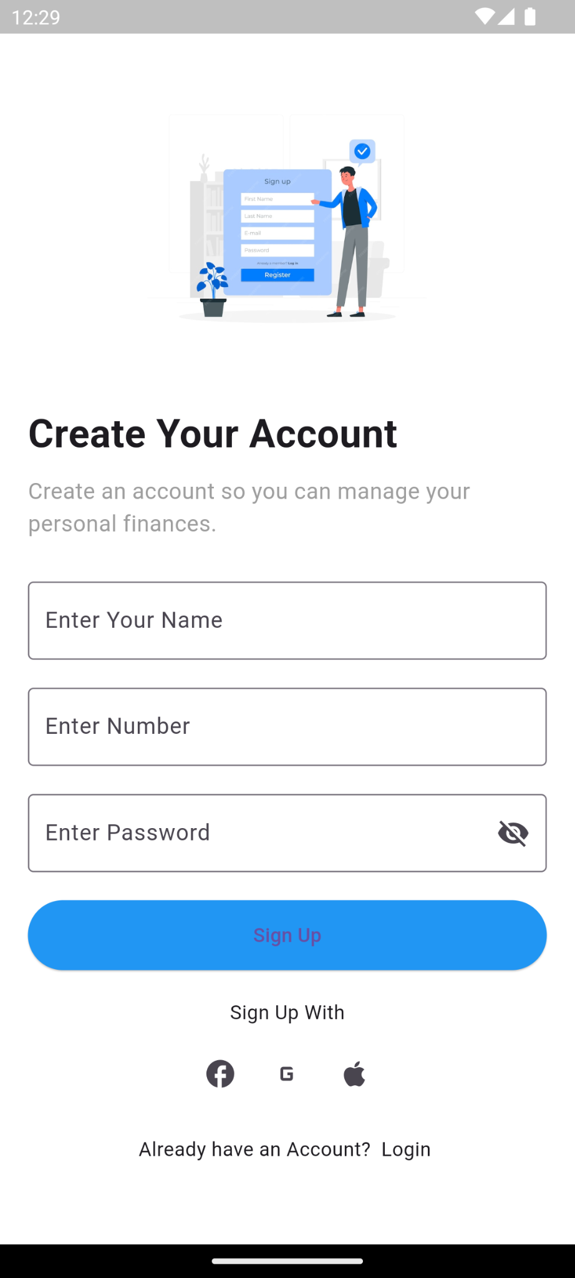

How to submit your Exercise
Push your project back to the same git branch using command:
<command name>

Happy Coding!

